**Task : Create a custom docker image for nginx and deploy it using docker-compose, where the volume mount should be at /var/opt/nginx location. Push the created custom docker image to your docker hub.**

**Creating custom Nginx image :**

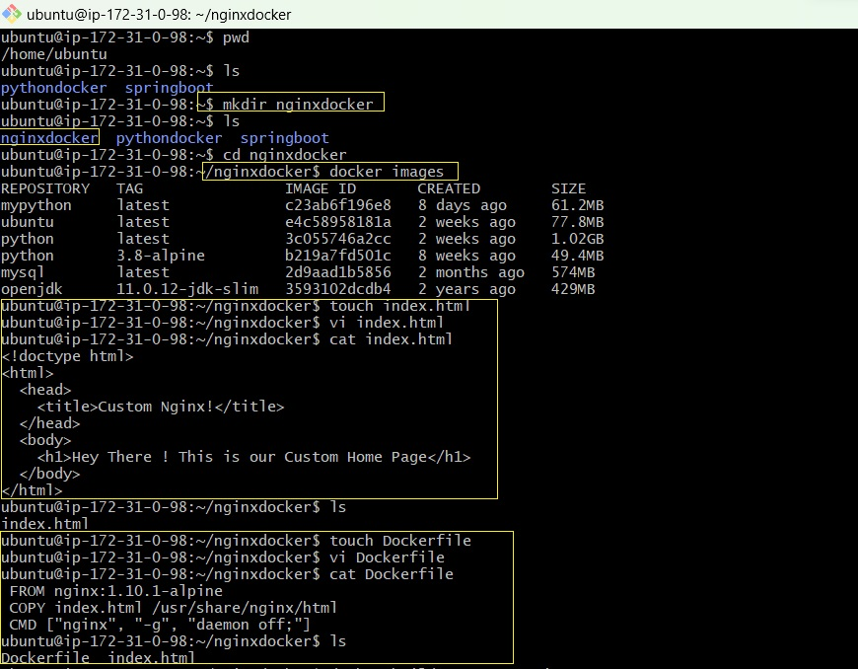

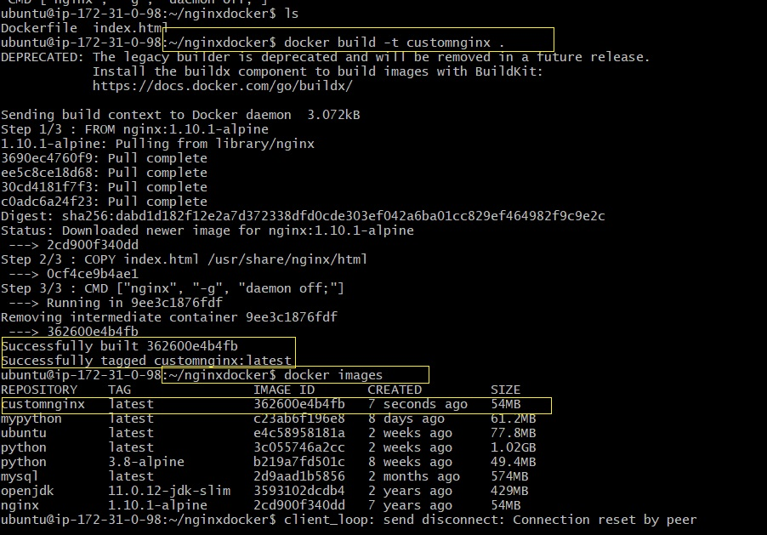

**Creating Docker Volume :**

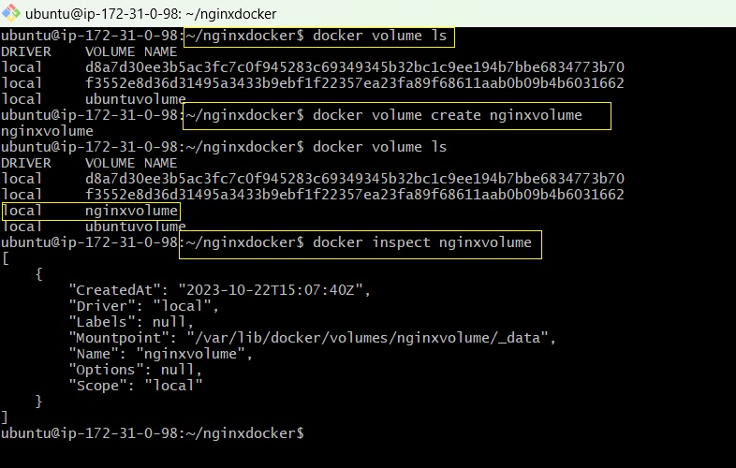

**Creating Docker Compose File :**

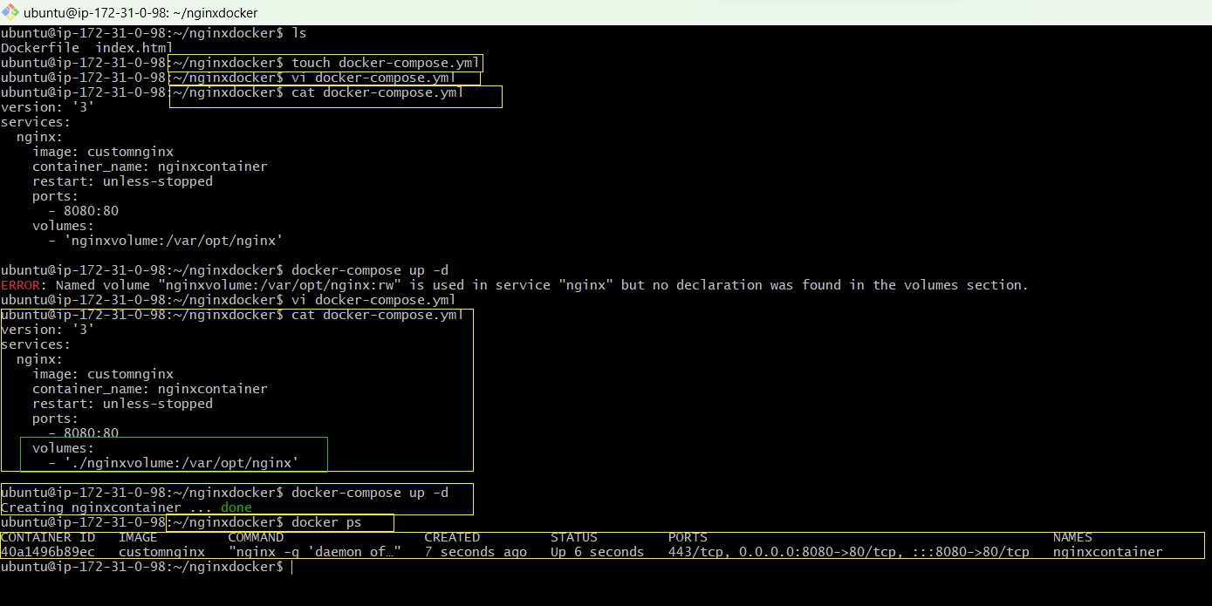

**Hitting my Custom Nginx Page :**

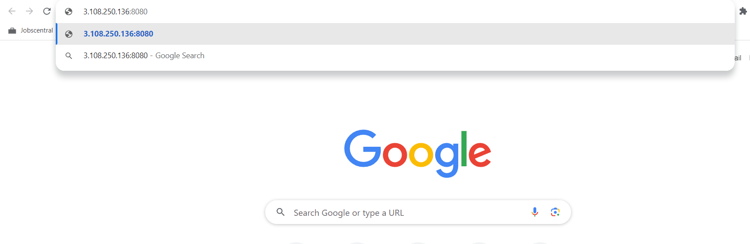



**Pushing the created custom docker image to my docker hub** :

